## Lab Manual

**Computer Networks**



## Faculty of Software Engineering SUPERIOR UNIVERSITY LAHORE PAKISTAN

**Introduction to Packet Tracer:**

# Lab 1

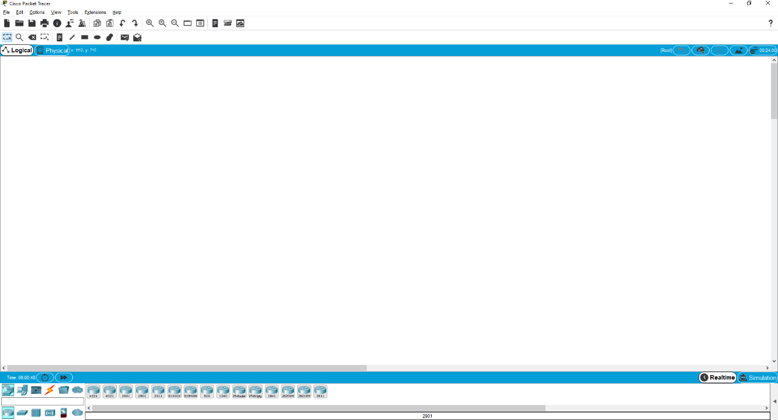

* Packet Tracer is a powerful router simulator created by Cisco Systems. It provides virtual interfaces to interact with physical environment.
* The purpose of Packet Tracer is to offer students and teachers a tool to learn the principles of networking as well as develop Cisco Technology specific skills.
* Packet Tracer is a simple Drag & Drop simulator that provides user-friendly environment.
* One of the biggest advantage of packet tracer is that when implementing a large scale of network in a physical environment it helps to establish the whole scenario in the simulator.
* Packet Tracer creates **.pkt & .pka** Extension when saving files.
* Packet Tracer **Include Routers, Switches, Hub, Servers, End Devices, Firewalls, And Multi user environment support**, so one can easily perform a large activity with its group members or partners on two computers. After completing of an activity both can merge a single Lab in one activity.

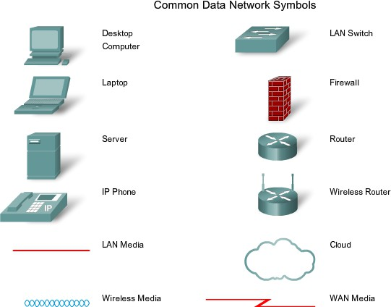

### Difference Between End & Intermediate devices: Intermediary devices:

A device that connects directly to end user devices or provides end user routing to other networks. For instance, a router is an example of intermediary devices Intermediary devices connect the individual hosts to the network and can connect multiple individual networks to form an internet-work.

### End Devices

The network devices that people are most familiar with are called end devices. These devices form the interface between the human network and the underlying communication network. Some examples of end devices are:

* Computers (work stations, laptops, file servers, web servers)
* Network printers
* VoIP phones
* Security cameras
* Mobile handheld devices (such as wireless barcode scanners, PDAs)

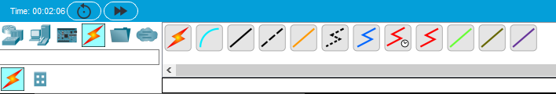

Selecting Connection Type

### Difference between Twisted Pair & Unshielded Twisted Pair:

**Twisted pair: Twisted pair** cabling is a type of wiring in which two conductors (the forward and return conductors of a single circuit) are twisted together for the purposes of canceling out electromagnetic interference (EMI) from external sources.

**UTP**: is a four –pair medium used in verity of networks. UTP does not require te fixed spacing connection that is necessary with coaxile type connection. UTP is also finding increasing use in video applications, primarily in security cameras. Many middle to high-end cameras include a UTP output with setscrew terminals. This is made possible by the fact that UTP cable bandwidth has improved to match the baseband of television signals

### Symbols of Cable Type:

**Console Cable (used to connect with a router) Straight Through Cable (Used to Connect Different Devices**

**Copper Crossover cable (Used to connect with the same devices) ** **Fiber (used in WAN environment)**

 **Phone (used in VOIP Phone)**

 **Coaxial cable (used in WAN emulation)**

 **Serial DCE Cable (Used in WAN links where clock rate is required) ** **Serial DTE Cable (used in WAN link where clock rate is not required)**

**Task 1;**

# Lab 1 - Task

What is the difference between all the routers, and when to use them (mentioned in cisco packet tracer)

1. **Cisco 4331 & 4321 Routers (ISR 4000 Series)**

* **Description:** Part of the **Integrated Services Router (ISR)** 4000 series, these routers provide advanced services like VPN, security, voice, and WAN optimization.
* **Use Case:** Suitable for **medium-to-large enterprises** with demanding requirements for security and application performance. Use them when advanced services are needed, such as encryption and deep packet inspection.

1. **Cisco 1941 & 2901 Routers (ISR G2 Series)**
   * **Description:** These are part of the **ISR Generation 2** series and offer security, unified communications, and WAN optimization in a smaller form factor.
   * **Use Case:** Best for **small-to-medium businesses** needing robust routing services. They can handle moderate traffic loads with some security and VPN requirements.
2. **Cisco 2911 Router**
   * **Description:** A versatile router that belongs to the **ISR G2 series**, which also supports modular interfaces and services.
   * **Use Case:** Used in **branch offices** or **medium-sized networks** with flexibility in WAN connections and VPNs.
3. **Cisco 819HGW & 819IOX Routers**
   * **Description:** These are rugged, compact routers designed for IoT and M2M (Machine-to-Machine) applications. They support **4G LTE** and wireless connections.
   * **Use Case:** Use in **mobile networks**, **remote locations**, or **IoT applications**, especially where size, mobility, and wireless access are critical.
4. **Cisco 829 Router**
   * **Description:** Another compact router designed for industrial, rugged, and IoT applications. It supports LTE and other wireless capabilities.
   * **Use Case:** Excellent for **IoT networks**, **mobile workforces**, or remote **industrial** locations.
5. **Cisco 1240 Router**
   * **Description:** A legacy router primarily used in industrial or rugged settings. It offers support for specific modules.
   * **Use Case:** Rarely used in modern setups but can be applied in **legacy network environments**.
6. **FR Router**
   * **Description:** The **Frame Relay Router** is used for simulating legacy Frame Relay networks.
   * **Use Case:** Use only for **simulating Frame Relay** networks, often in educational environments to learn about legacy WAN technologies.
7. **Empty Router**
   * **Description:** This represents an **empty chassis** where you can add or remove modules based on your network needs.
   * **Use Case:** It’s used to **customize** router configurations for specific network setups in labs.
8. **Cisco 1841 Router**
   * **Description:** A popular router in the **ISR G1** series, designed for small businesses and branch offices.
   * **Use Case:** Suitable for **small office/home office (SOHO)** environments, with basic routing and security capabilities.
9. **Cisco 2620XM & 2811 Routers**
   * **Description:** Older routers that support basic routing, VPNs, and security services. They are modular and allow for the addition of various interfaces.
   * **Use Case:** Best for **educational purposes** or for small businesses with minimal routing needs.

### Task 2;

What is the difference between all the switches, and when to use them (mentioned in cisco packet tracer)

1. **Cisco 2960 Switch**
   * **Description:** This is a Layer 2 switch that provides basic switching capabilities like MAC address learning and VLAN support. It doesn’t offer Layer 3 routing features.
   * **When to Use:** Great for **small networks** or **LANs** where you only need simple device connectivity without advanced routing.
2. **PT-Switch**
   * **Description:** This is a basic, simulated switch in Packet Tracer designed for quick lab setups. It provides basic Layer 2 functionalities.
   * **When to Use:** Best for **educational purposes** or quick network setups where no advanced configurations are needed.
3. **PT-Empty**
   * **Description:** Represents an **empty chassis** switch, which allows you to add different modules based on your network needs.
   * **When to Use:** Use when you want to **customize** a switch configuration by adding or removing modules depending on your lab requirements.
4. **Cisco 3560-24PS Switch**
   * **Description:** A **Layer 3 switch** that supports routing between VLANs. It also has **Power over Ethernet (PoE)**, which can provide power to devices like IP phones or wireless access points.
   * **When to Use:** Ideal for **medium-sized networks** where you need to route traffic between VLANs and power devices using PoE.
5. **Cisco 3560-24PS (Duplicate)**
   * **Description:** This appears to be the same model as the previous one, likely included twice in the interface. It has the same functionality as the switch described above.
6. **IE 2000 Switch**
   * **Description:** The **Cisco IE 2000** is an industrial-grade switch designed for **rugged environments**. It supports automation and IoT networks and is built to handle harsh conditions.
   * **When to Use:** Perfect for **industrial applications** such as manufacturing plants, oil rigs, or remote outdoor deployments.
7. **PT-Bridge**
   * **Description:** This is a simple bridge device used to connect different network segments.
   * **When to Use:** Best for **educational purposes** when learning about network segmentation or bridging two different network segments together.
8. **Cisco 2950-24 Switch**
   * **Description:** This is a legacy **Layer 2 switch** offering basic VLAN segmentation and switching functionalities. It doesn't support Layer 3 routing.
   * **When to Use:** Suitable for **small office networks** or educational labs where basic switching is required without the need for advanced features.
9. **Cisco 2950T Switch**
   * **Description:** Similar to the 2950-24, but this model may come with **additional uplink ports** (typically fiber). It provides basic Layer 2 switching functionalities.
   * **When to Use:** Also ideal for **small networks** but with a focus on **uplink connectivity** for faster inter-switch links.

### Task 3;

What is the difference between all the connection wires, and when to use them (mentioned in cisco packet tracer)

• **Solid Line (Direct Connection)**:

* This is a standard wire for connecting two points directly without any modification to the signal.
* **When to Use**: Use this when you want a direct electrical connection between two points with no signal alteration.

• **Curved Wire**:

* This type of connection allows the wire to be bent or routed smoothly in curves.
* **When to Use**: Useful for keeping circuit diagrams clean and readable when you want to avoid crossing wires.

• **Dashed or Dotted Line (Ground/Earth Connection)**:

* Dotted or dashed lines typically represent connections to the ground or special types of connections like references.
* **When to Use**: For grounding signals or connecting to a reference point.

• **Arrowed Wire**:

* This wire type may indicate the direction of signal flow or a voltage-controlled source.
* **When to Use**: Use in places where the direction of the current or signal flow is important to understand.

• **Zigzag Wires (Resistive or Inductive Connections)**:

* The zigzag could represent resistive or inductive characteristics in the connection.
* **When to Use**: When you need to show connections that introduce impedance like resistors or inductors in the system.

• **Colored Wires**:

* Different colors often represent different signal types, such as power, data, control, or signals with different voltages.
* **When to Use**: Use colors to differentiate between types of connections like analog vs. digital signals, high power vs. low power, etc.

• **Shorted Wire with a Dot**:

* This often represents a crossing connection point where two or more wires are connected.
* **When to Use**: Use this when you are connecting wires in a junction.

• **Zigzag with Circular Mark**:

* This may represent some specialized connection, possibly a variable resistor or other dynamic components.
* **When to Use**: When you need to represent a variable or controlled signal in a circuit.